Case Study: Title, [Gait Lab Name]
Introduction to case
- Brief description of patient (age, condition etc.) and reason for referral
- Please make sure presented study is completely anonymised and pictures are free of any distinguishing features (faces, ‘name’ etc.)
- Abstracts must not exceed one A4 page. Please submit in Word format to allow any minor formatting edits that may be required for inclusion in the programme.
Data Collected
- Tests/technology used in the analysis session
- Any difficulties in data collection (compliance, comprehension)
Findings
- Present most relevant data from the tests conducted
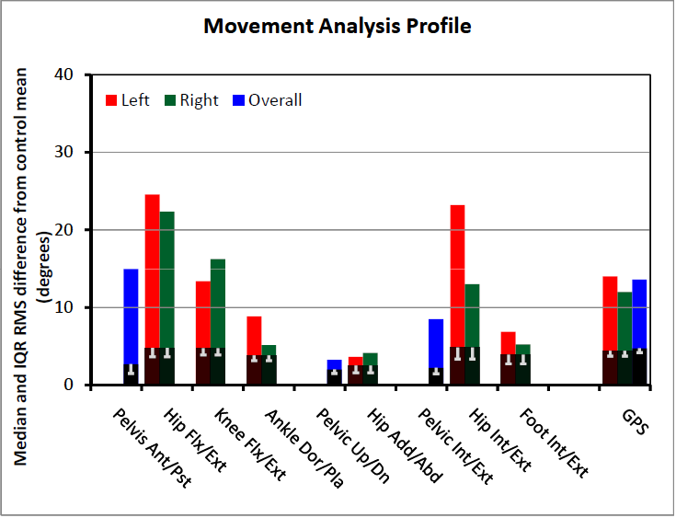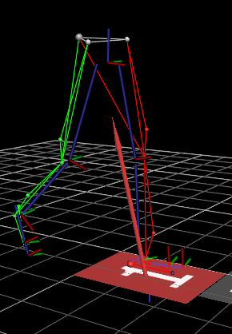
Figure 1: Please place figure captions below figures and use black Arial font, 8pt

Conclusion and Recommendations
- Key findings of the gait analysis and recommendations made
- Any relevant information from follow-up?

Discussion points
Any particular points from clinical or technological aspects of the gait analysis case that are instructive or worthy of further discussion?

