Title of study
[Author 1]¹, [Author 2]²
- Author 1 affiliation, [contact email]
- Author 2 affiliation

Introduction
Abstracts must not exceed one A4 page. Please submit in Word format to allow any minor formatting edits that may be required for inclusion in the programme. Please denote any references using superscript¹ and use Vancouver referencing style. Please keep sections arranged in the order: ‘Introduction’, Materials and methods’, Results’, ‘Discussion’, ‘Conclusion’

Materials and methods
Materials and methods section, Materials and methods section, Materials and methods section, Materials and methods section, Materials and methods section, Materials and methods section, Materials and methods section, Materials and methods section, Materials and methods section, Materials and methods section, Materials and methods section, Materials and methods section,

Results
Results section, Results section, Results section, Results section, Results section, Results section,
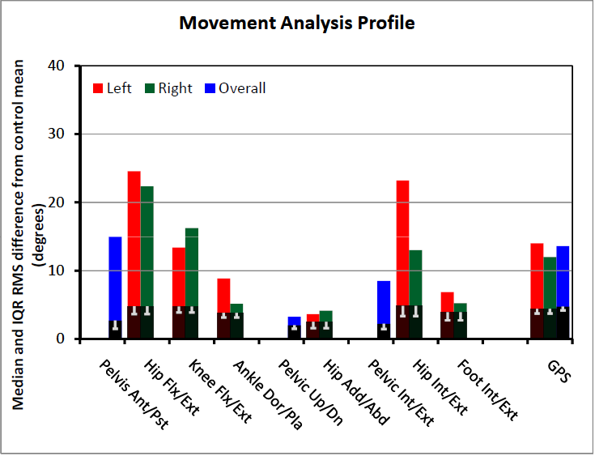
Figure 1: Please place figure captions below figures and use black Arial font, 8pt
Results section, Results section, Results section, Results section, Results section, Results section, Results section, Results section, Results section, Results section, Results section, Results section, Results section, Results section, Results section, Results section, Results section.
Table 1: Please place table captions above table and use black Arial font, 8pt
Edinburgh Gait Score | Left | Right
 | Barefoot | Barefoot
01/12/2021 | 6-7 | 9-10

Discussion
Discussion section, Discussion section, Discussion section, Discussion section, Discussion section, Discussion section, Discussion section, Discussion section, Discussion section, Discussion section, Discussion section, Discussion section, Discussion section, Discussion section, Discussion section, Discussion section, Discussion section, Discussion section,

Conclusion
Conclusion section, Conclusion section, Conclusion section, Conclusion section,

References
- Author et al.
- Author et al.

